 | 12.3.7 Editors - Geometry Nodes Editor - Sidebar - Add tab
Table of content
Add tab 1

Add tab

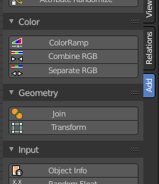
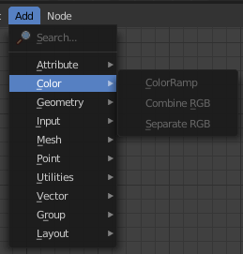
The add tab contains the content of the Add menu from the header. There is no difference in the content.
The only difference is, the sidebar and the panels stays open, and you can see all possible nodes at once. Which allows a much faster workflow.

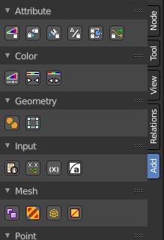
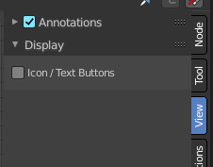
You can switch the display of the panel content from icon and text display to pure icon display in the View tab in the Display panel. The Icon / Text checkbox.

